**Week 8**

**5.Git-HOL HandsOn**

1. 
2. 
3. 

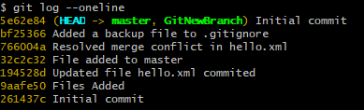

1. 

